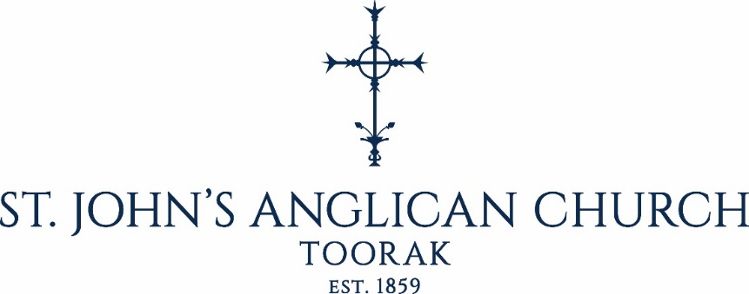

APPLICATION FOR BAPTISM – Adult Candidate
Name of Candidate:
Proposed Date of Baptism:
Sunday | / / |  | at |  |  | AM/PM
Approximate Number of Guests:

PLEASE RETURN TO:
St John’s Parish Office
86 Clendon Road
Toorak 3142
Email: enquiries@saintjohnstoorak.org
Telephone: (03) 9826 1765
ABOUT BAPTISM
Baptism marks the beginning of a journey with God which continues for the rest of our lives. It is a first step we take in response to God’s love. For all involved, particularly the candidates but also family and sponsors, it is a joyful and unrepeatable moment when we rejoice in what God has done for us in Christ, make some serious promises, and declare our faith. Hearing and doing these things provides those who are already baptised an opportunity to remember our own baptism and reflect on the progress made on that journey, which is now to be shared with this new member of the Church.
The service paints many vivid pictures of what happens on the Christian way. There is the sign of the cross, the badge of faith in the Christian journey, which reminds us of Christ’s death for us. Our ‘drowning’ in the water of baptism, where we believe we die to sin and are raised to new life, unites us to Christ’s dying and rising. Water is also a sign of new life, as we are born again by water and the Spirit, as Jesus was at his baptism. And as a sign of that new life, there is a lighted candle, a picture of the light of Christ conquering the darkness of evil. Everyone who is baptised walks in that light for the rest of their lives.
Adapted from Common Worship: Services and Prayers for the Church of England, © 2000.

AFTER THE BAPTISM
All who are baptised should be further formed and instructed in the Christian faith by attending services of worship, ideally in the church where the Baptism took place.
Services at St. John’s Toorak are every Sunday at 8am and 10am, the latter service includes Sunday School.
All services are in the Anglican tradition and include Holy Communion. All are welcome.

www.saintjohnstoorak.org

Candidate:
Date of birth:

Address:
Email:
Telephone:

Sponsors’ Names in Full
1.
2.
3.

For further information about Baptism, please contact the
Parish Office.
Phone: 03 98261765 Email: enquiries@saintjohnstoorak.org

